Delivering luxuries and comforts valuates a firm!

The intrinsic value for the food delivery apps relies solely on their effective features, restaurants accessible, offers available, delivery time, and customer support services. Traffic rush, Full dining areas, Huge Waiting time, all these tedious matters are a good step away with the anywhere and anytime food deliveries.

Food delivery apps are for us as the table cloth of Doraemon was for Nobita! A few touches and the order is placed! Then a few minutes and the food is there! Now we have the delivery made easy with Deliveroo, and of course many others!

66% of the restaurant owners stated the increase in their sales with online delivery with 33% of customers willing to pay more for faster-paced deliveries.

Zomato, Swiggy, Uber Eats, FoodPanda, Dilveroo, Domino’s, Just Eat, and GrubHub are few of the top delivery hubs taking food dining and comfort to the next level of pleasure. Have a look at the app usage shared by Statista from across the globe. (image for background)

Considering the delivery charges to be the primary revenue source, the top food delivery apps have their delivery prices fixed across the globe. This is the list for the fixed charges as analyzed by the RubyGarage (to be displayed in the background)…

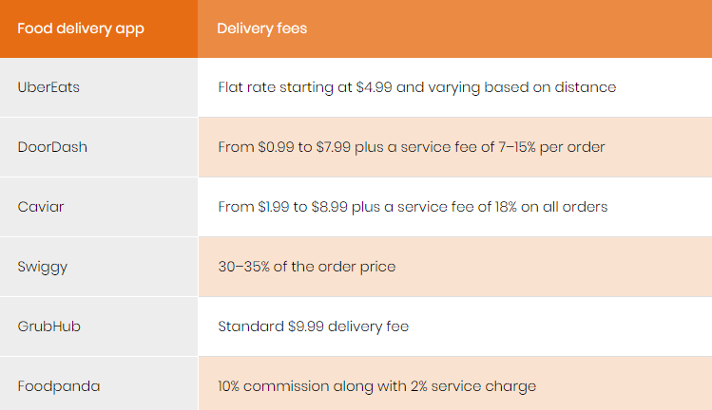

With every 100 orders, GrubHub registered restaurants saves about 2.5 of the worker’s time.

* FoodPanda has been operational over 41 countries globally with a revenue of 11.7 million euros in 2016.
* Zomato is the food delivery app with its usage across the 25 global countries with $68 million of revenue generation in 2019.
* Uber Eats extends its market over 1,000+ major cities and values about $20 million according to the global media reports.
* Deliveroo is a London based startup working around 200 cities. And, GrubHub is noted to satisfy over 800 US communities.

In 2019, 37.6% of the orders were made by the age group of 25-35 years as stated by Statista Global Consumer Survey with 69.7% being the males.

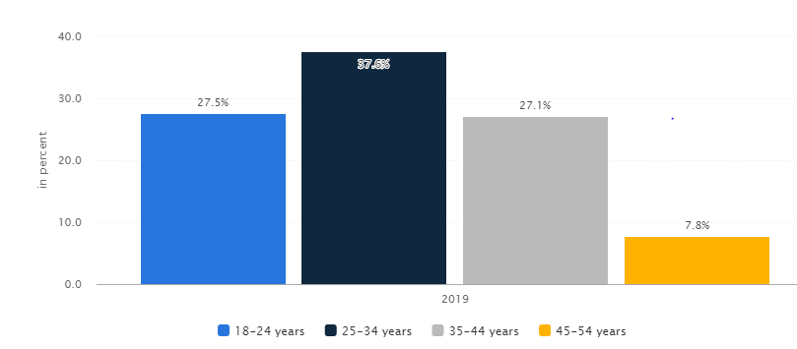

Delivery sales are expected to rise by 20% from 2020 to 2030 as the graph below displays.

The pandemic lockdown has no negative effects on the food delivery market. In fact, there has been a rise of 3.868% from February in the food delivery market. Upserve states that 7% of the restaurant using online deliveries experienced an over 60% increase in February sales.

Asia accounts for 55% of the global food delivery market. It is the delivery that makes the restaurants success!